VETERINARY MEDICINES DIRECTORATE
P.O. Box 66171-00800
Westlands, Nairobi
Telephone: 0743795395
Email: info@vmd.go.ke

REGISTRATION REF NAME: REGISTRATION OF SUPPLIERS FOR PROCUREMENT AND SUPPLY FOR PROVISION OF NON- CONSULTING SERVICES

REGISTRATION REF NO: MOALF&C /VMD/REG/04/2022-2023

REGISTRATION DOCUMENT FOR NON-CONSULTING SERVICES

INVITATION FOR REGISTRATION NO.: MOALF&C /VMD/REG/04/2022-2023

CONTRACT NAME: REGISTRATION OF SUPPLIERS FOR PROCUREMENT AND SUPPLY FOR PROVISION OF NON-CONSULTING SERVICES.
PROCURING ENTITY: VETERINARY MEDICINES DIRECOTRATE
ISSUED ON: 23RD MARCH 2023

(THIS REGISTRATION DOCUMENT IS FOR USE WITH A STANDARD TENDER DOCUMENT INVITING FOR TENDERS)

CATEGORY APPLIED FOR………………………………………………………………………………………….

VETERINARY MEDICINE DIRECTORATE

TABLE OF CONTENTS

INVITATION TO APPLY FOR REGISTRATION vii
PART 1-APPLICATION PROCEDURES 1
Section I - Instructions to Applicants (ITA) 1
- General 1
  - Scope of Application 1
  - Source of Funds 1
  - Fraud and Corruption 1
4.. Collusive practices 1
- Eligible Applicants 1
- Eligibility 2
- Pre-qualiﬁcation Documents 3
- Sections of Pre-qualiﬁcation Document 3
PART 1 -Pre-qualiﬁcation Procedures 3
- Section I - Instructions to Applicants (ITA) 3
- Section II - Pre-qualiﬁcation Data Sheet (PDS) 3
- Section III - Qualiﬁcation Criteria and Requirements 3
- Section IV -Application Forms 3
PART 2 – Scope of Non-Consulting Services Requirements 3
Section VII – Scope of Non-Consulting Services Requirements 3
- Clariﬁcation of Pre-qualiﬁcation Document and Pre-Application Meeting 3
- Amendment of Pre-qualiﬁcation Document 4
- Preparation of Applications. 4
- Cost of Applications 4
- Language of Application 4
- Documents Comprising the Application 4
- Application Submission Letter 4
- Documents Establishing the Eligibility of the Applicant 4
- Documents Establishing the Qualiﬁcations of the Applicant 4
- Signing of the Application and Number of Copies 5
- Submission of Applications 6
- Sealing and Marking of Applications 6
- Deadline for Submission of Applications 6
- Late Applications 6
- Opening of Applications 6
- Procedures for Evaluation of Applications 6
- Conﬁdentiality 6
- Clariﬁcation of Applications 6
- Responsiveness of Applications 7
- Margin of Preference 7
- Nominated Subcontractors 7
- Evaluation of Applications and Pre-qualiﬁcation of Applicants 7
- Evaluation of Applications 7
- Procuring Entity's Right to Accept or Reject Applications 8
- Pre-qualiﬁcation of Applicants 8
- Notiﬁcation of Pre-qualiﬁcation 8
- Invitation to Tender 8
- Changes in Qualiﬁcations of Applicants 8
- Procurement Related Complaint 8
Section II - Pre-qualiﬁcation Data Sheet (PDS) 9
Section III- Qualiﬁcation Criteria and Requirements 12
Section IV –Application Forms 20
- Application Submission Letter 20
- Form ELI -1.1 - Applicant Information Form 22
- Form ELI -1.2 - Applicant's JV Information Form 23
- Form CON - 2 - Historical Contract Non-Performance, and Pending Litigation andLitigation History 24
- Form FIN - 3.1 -Financial Situation and Performance 25
- Form FIN - 3.2 - Average Annual Construction or Supply Contracts Turnover 27
- Form EXP - 4.1- General Construction or Supply Contract Experience (Select one) 29
- Form EXP - 4.2(a) - Speciﬁc Construction and Contract Management Experience or Supply Contract Experience 30
10. Form EXP - 4.2(b) - Construction Experience or Supply contract in Key Activities (select one) 32

INVITATION FOR REGISTRATION OF SUPPLIERS AND CONTRACTORS

REGISTRATION REFERENCE NO: VMD/REG/04/2022 -2023

REGISTRATION REFERENCE NAME: REGISTRATION OF SUPPLIERS FOR
PROCUREMENT AND SUPPLY FOR PROVISION OF GOODS AND NON- CONSULTING SERVICES

REGISTRATION PERIOD: TWO YEARS
The Veterinary Medicine Directorate intends to Register Suppliers/Service Providers for the listed categories: -

- PROVISION OF GOODS AND NON-CONSULTING SERVICES
CATEGORY NO. | CATEGORY DESCRIPTION | ELIGIBILITY | CLOSING DATE
VMD 9 | SUPPLY OF MINERAL BOTTLED WATER | OPEN FOR ALL
VMD 13 | Provision of Travel and Ticketing services (IATA registered firms only) | RESERVED FOR AGPO REGISTERED FIRMS | 11/04/2023 AT 10:00AM
VMD21 | PROVISION OF INTERNET SERVICES | OPEN FOR ALL | 11/04/2023 AT 10:00AM
VMD 33 | SUPPLY OF AIRTIME | OPEN FOR ALL | 11/04/2023 AT 10:00AM
VMD 34 | GENERAL OFFICE SUPPLIES | RESERVED FOR PWD | 11/04/2023

Qualiﬁed and interested applicants may obtain detailed information the registration of suppliers’ document from the Veterinary Medicine Directorate website www.vmd.go.ke.

A complete set of Registration Document in English will be obtained electronically from the Website www.vmd.go.ke free of charge.

Any addendum or clarification will be posted in the veterinary medicine directorate website www.vmd.go.ke. Seven Days prior to the closing date
.
Applications for Registration document are to be enclosed in plain sealed envelopes clearly marked with the Registration Reference No. Category Description and Category No. should be dropped in the tender box Marked Veterinary Medicine Directorate situated at PCPB Plaza, Loresho Ridge Plaza Ground Floor Reception, or posted to the address provided below:

The Chief Executive Officer Veterinary Medicine Directorate
P.O Box 66171-00100 NAIROBI
Loresho Ridge Plaza, Nairobi at 10.00 a.m. East African Time Room 6 Attn: Emily Githinji

Tenders will be opened immediately thereafter in the presence of the Candidate or their representatives who choose to attend at the Committee Room, 6 ground floor VMD Offices.

Electronic submissions shall not be accepted. Late applications are liable to be rejected.

Yours Sincerely,
Dr Jane Njiru
CHIEF EXECUTIVE OFFICER

PART 1 - APPLICATION PROCEDURES

SECTION I - INSTRUCTIONS TO APPLICANTS (ITA)

General

Scope of Application

    - The name of the Procuring Entity inviting for applications is deﬁned in the PDS. The particular type of contract (Non-Consulting Services required) and its name and description of the contract(s) and its reference number are deﬁned in the PDS. If the scope of contract so deﬁned is in multiple contracts, it will be speciﬁed in the PDS if Registration will be based on individual contracts or multiple contracts. The Full scope of goods and Non-Consulting Services are described in Section V.

  - Source of Funds to be speciﬁed in the PDS, if deemed necessary.

Fraud and Corruption

    - The Government of Kenya requires compliance with its Anti-Corruption laws and its prevailing sanctions policies and procedures.

    - In further pursuance of this policy, Applicants shall permit and shall cause their agents (where declared or not), subcontractors, sub consultants, service providers, suppliers, and their personnel, to permit the Public Procurement Regulatory Authority (PPRA) to inspect all accounts, records and other documents relating to any initial selection process, Registration process, tender submission(incase prequaliﬁed),proposal submission, and contract performance (in the case of award), and to have them audited by auditors appointed by the PPRA.

Collusive practices

  - The Procuring Entity requires compliance with the provisions of the Competition Act 2010, regarding collusive practices in contracting. Any applicant found to have engaged in collusive conduct shall be disqualiﬁed and criminal and/or civil sanctions may be imposed. To this effect, applicants shall be required to complete and sign a Certiﬁcate of Independent Tender Determination” annexed to the Form of applicant.

Eligible Applicants

  - Applicants shall meet the eligibility criteria as per this ITA and ITA 5.1and 5.2. An Applicant may be a ﬁrm that is a private entity, a state-owned enterprise or institution subject to ITA 5.9 or any combination of such entities in the form of a joint venture (“JV”) under an existing agreement or with the intent to enter into such an agreement supported by a letter of intent. In the case of a joint venture, all members shall be jointly and severally liable for the execution of the entire Contract in accordance with the Contract terms. The JV shall nominate a Representative who shall have the authority to conduct all business for and on behalf of any and all the members of the JV during the Registration process, tendering (in the event the JV submits a Tender) and during contract execution (in the event the JV is awarded the Contract). Members of a joint venture may not also make an individual tender, be a subcontractor in a separate tender or be part of another joint venture for the purposes of the same Tender. The maximum number of JV members shall be speciﬁed in the PDS.

  - Public Ofﬁcers of the Procuring Entity, their Spouses, Child, Parent, Brothers or Sister. Child, Parent, Brother or Sister of a Spouse, their business associates or agents and ﬁrms/organizations in which they have a substantial or controlling interest shall not be eligible to be prequaliﬁed. Public Ofﬁcers with such relatives are also not allowed to participate in any procurement proceedings.

  - A ﬁrm may apply for Registration both individually, and as part of a joint venture, or participate as a subcontractor. If prequaliﬁed, it will not be permitted to tender for the same contract both as an individual ﬁrm and as a part of the joint venture or as a subcontractor. However, a ﬁrm may participate as a subcontractor in more than one Tender, but only in that capacity. Tenders submitted in violation of this procedure will be rejected.
  - A ﬁrm and any of its afﬁliates (that directly or indirectly control, are controlled by or are under common control with that ﬁrm) may submit its application for Registration either individually, as joint venture or as a subcontractor among them for the same contract. However, if prequaliﬁed, only one prequaliﬁed Applicant will be allowed to tender for the. All Tenders submitted in violation of this procedure will be rejected.

  - An Applicant may have the nationality of any country, subject to the restrictions pursuant to ITA 5.1 and 5.2. An Applicant shall be deemed to have the nationality of a country if the Applicant is constituted, incorporated or registered in and operates in conformity with the provisions of the laws of that country, as evidenced by its articles of incorporation (or equivalent documents of constitution or association) and its registration documents,

as the case may be sub-contractors or suppliers for any part of the Contract including related Non-Consulting Services.

  - Applicants shall not have a conﬂict of interest. Applicants shall be considered to have a conﬂict of interest, if they, or any of their afﬁliates, participated as a consultant in the preparation of the design or technical speciﬁcations or have been hired or proposed to be hired by the Procuring Entity as Engineer for contract implementation of the contract(s) that are the subject of this Registration. In addition, Applicants may be considered to have a conﬂict of interest if they have a close business or family relationship with a professional staff of the Procuring Entity who:
    - Are directly or indirectly involved in the preparation of the Registration Document or Invitation to Tender (ITT), Document or speciﬁcations of the Contract, and/or the Tender evaluation process of such Contract; or
    - Would be involved in the implementation or supervision of such Contract, unless the conﬂict stemming from such relationship has been resolved in a manner acceptable to the Procuring Entity throughout the Registration, ITT process and execution of the Contract.

  - An Applicant that has been debarred shall be ineligible to be initially selected for, prequaliﬁed for, tender for, propose for, or be awarded a contract during such period of time as the PPRA shall have determined. The list of debarred ﬁrms and individuals is available at www.ppra.go.ke

  - Applicants that are state-owned enterprise or institutions in Kenya may be eligible to prequalify, compete and be awarded a Contract(s) only if they can establish, in a manner accept able to the Procuring Entity, that they (i) Are legally and ﬁnancially autonomous (ii) Operate under commercial law, and (iii) Are not under supervision of any public entity.

  - An Applicant shall not be under sanction of debarment from Tendering by the PPRA as the result of the execution of a Tender/Proposal–Securing Declaration.

  - An Applicant that is a Kenyan ﬁrm or citizen shall provide evidence of having fulﬁlled his/her tax obligations by producing a current tax clearance certiﬁcate or tax exemption certiﬁcate issued by the Kenya Revenue Authority.

  - An Applicant shall provide any other such documentary evidence of eligibility satisfactory to the Procuring Entity, as the Procuring Entity shall reasonably request.

Eligibility

  - Firms and individuals may be ineligible if they are nationals of ineligible countries as indicated herein. The countries, persons or entities are in eligible if:
- As a matter of law or ofﬁcial regulations, Kenya prohibits commercial relations with that country, or
- By an act of compliance with a decision of the United Nations Security Council taken under Chapter VII of the Charter of the United Nations, Kenya prohibits any import of goods or contracting of works or Non- Consulting Services from that country, or any payments to any country, person, or entity in that country.

  - When the supply of Goods or provision of non-consulting services are implemented a cross jurisdictional boundary (and more than one country is a Procuring Entity, and is involved in the Procurement), then exclusion of a ﬁrm or individual on the basis of ITA 5.1 (a) above by any country may be applied to that procurement a cross other countries involved, if the Procuring Entities involved in the procurement so agree.

  - Any goods and production processes with characteristics that have been declared by the relevant national environmental protection agency or by other competent authority as harmful to human beings and to the environment shall not be eligible to procurement.

Contents of the Registration Documents

- Sections of Registration Document

  - This Registration Document consists of parts1 and 2 which comprise all the sections indicated below, and which should be read in conjunction with any Addendum issued in accordance with IT A8.

PART 1 - Registration Procedures
- Section I- Instructions to Applicants (ITA)
- Section II - Registration Data Sheet (PDS)
- Section III - Qualiﬁcation Criteria and Requirements
- Section IV- Application Forms

PART 2 - Goods and Non-Consulting Services Requirements

i) Section VII- Scope of Goods and Non-Consulting Services

  - Unless obtained directly from the Procuring Entity, the Procuring Entity accepts no responsibility for the completeness of the document, responses to requests for clariﬁcation, the minutes of the pre-Application meeting (if any), or Addenda to the Registration Document in accordance with ITA 8. In case of any discrepancies, documents issued directly by the Procuring Entity shall prevail.

  - The Applicant is expected to examine all instructions, forms, and terms in the Registration Document and to furnish with its application all information or documentation as is required by the Registration Document.

Clariﬁcation of Registration Documents, site visit(s) and Pre-Application Meeting

  - An Applicant requiring any clariﬁcation of the Registration Document shall contact the Procuring Entity in writing at the Procuring Entity's address indicated in the PDS. The Procuring Entity will respond in writing to any request for clariﬁcation provided that such request is received no later than fourteen (14) days prior to the deadline for submission of the applications. The Procuring Entity shall forward a copy of its response to all prospective Applicants who have obtained the Registration Document directly from the Procuring Entity, including a description of the inquiry but without identifying its source. If so, indicated in the PDS, the Procuring Entity shall also promptly publish its response at the webpage identiﬁed in the PDS. Should the Procuring Entity deem it necessary to amend the Registration Document as a result of a clariﬁcation, it shall do so following the procedure under ITA 8. And in accordance with the provisions of ITA17.2.

  - The Applicant, at the Applicant's own responsibility and risk, is encouraged to visit and examine and inspect the Site of the required contracts and obtain all information that may be necessary for preparing the application. The costs of visiting the Site shall be at the Applicant's own expense. The Procuring Entity shall specify in the PDS if a pre-application meeting will be held, when and where. The Procuring Entity shall also specify in the PDS if a pre-arranged Site visit will be held and when. The Applicant's designated representative is invited to attend a pre- application meeting and a pre-arranged site visit. The purpose of the meetings will be to clarify issues and to answer questions on any matter that may be raised at that stage.

  - The Applicant is requested to submit any questions in writing, to reach the Procuring Entity not later than the period speciﬁed in the PDS before the submission date of applications.

  - Minutes of a pre-arranged site visit and those of the pre-application meeting, if applicable, including the text of the questions asked by Applicants and the responses given, together with any responses prepared after the meeting, will be transmitted promptly to all Applicants who have acquired the Registration documents. Minutes shall not identify the source of the questions asked.

  - The Procuring Entity shall also promptly publish anonymized (no names) Minutes of the pre-arranged site visit and those of the pre-proposal meeting at the web page identiﬁed in the PDS. Any modiﬁcation to the Registration Documents that may become necessary as a result of the pre-arranged site visit and those of the pre- application meeting shall be made by the Procuring Entity exclusively through the issue of an Addendum pursuant to PDS 8 and not through the minutes of the pre-application meeting. Non-attendance at the pre- arranged site visit and the pre-tender meeting will not be a cause for disqualiﬁcation of a Tenderer.

Amendment of Registration Document

  - At any time prior to the deadline for submission of Applications, the Procuring Entity may amend the Registration Document by issuing an Addendum.

  - Any Addendum issued shall be part of the Registration Document and shall be communicated in writing to all Applicants who have obtained the Registration Document from the Procuring Entity. The Procuring Entity shall promptly publish the Addendum at the Procuring Entity's webpage identiﬁed in the PDS.

  - To give Applicants reasonable time to take an Addendum into account in preparing their Applications, the Procuring Entity may, at its discretion, extend the deadline for the submission of Applications in accordance with ITA 17.2.

Preparation of Applications

Cost of Applications

  - The Applicant shall bear all costs associated with the preparation and submission of its Application. The Procuring Entity will in no case be responsible or liable for those costs, regardless of the conduct or outcome of the Registration process.

Language of Application

  - The Application as well as all correspondence and documents relating to the Registration exchanged by the Applicant and the Procuring Entity, shall be written in English Language. Supporting documents and printed literature that are part of the Application may be in another language, provided they are accompanied by an accurate translation of the relevant passages in the English language, in which case, for purposes of interpretation of the Application, the translation shall govern.

Documents Comprising the Application

  - The Application shall comprise the following:
- Application Submission Letter, in accordance with ITA 13.1;
- Eligibility: documentary evidence establishing the Applicant's eligibility, in accordance with ITA 14.1;
- Qualiﬁcations: documentary evidence establishing the Applicant's qualiﬁcations, in accordance with ITA 15; and
- Any other document required as speciﬁed in the PDS.

  - The Applicant shall furnish information on commissions and gratuities, if any, paid or to be paid to agents or any other party relating to this Application.

Application Submission Letter

  - The Applicant shall complete an Application Submission Letter as provided in Section IV (Application Forms). This Letter must be completed without any alteration to its format.

Documents Establishing the Eligibility of the Applicant

  - To establish its eligibility in accordance with ITA 4, the Applicant shall complete the eligibility declarations in the Application Submission Letter and Forms ELI (eligibility) 1.1 and 1.2, included in Section IV (Application Forms).

Documents Establishing the Qualiﬁcations of the Applicant

  - To establish its qualiﬁcations to perform the contract(s) in accordance with Section III, Qualiﬁcation Criteria and Requirements, the Applicant shall provide the information requested in the corresponding Information Sheets included in Section IV (Application Forms).

  - Wherever an Application Form requires an Applicant to state a monetary amount, Applicants should indicate the Kenya Shilling equivalent using the rate of exchange determined as follows:
- For construction turnover or ﬁnancial data required for each Year-Exchange rate prevailing on the last day of the respective calendar year (in which the amounts for that year is to be converted).
- Value of single Contract-Exchange rate prevailing on the date of the contract.
  - Exchange rates shall be taken from the publicly available source identiﬁed in the PDS. Any error in determining the exchange rates in the Application may be corrected by the Procuring Entity.

  - Applicants shall be asked to provide, as part of the data for qualiﬁcation, such information, including details of ownership, as shall be required to determine whether, according to the classiﬁcation established by the Procuring Entity, a particular contractor or group of contractors qualiﬁes for a margin of preference. Further the information will enable the Procuring Entity identify any actual or potential conﬂict of interest in relation to the procurement and/or contract management processes, or a possibility of collusion between Applicants, and thereby help to prevent any corrupt inﬂuence in relation to the procurement processor contract management.

  - The purpose of the information described in ITT 6.2 above overrides any claims to conﬁdentiality which an Applicant may have. There can be no circumstances in which it would be justiﬁed for an Applicant to keep information relating to its ownership and control conﬁdential where it is tendering to undertake public sector work and receive public sector funds. Thus, conﬁdentiality will not be accepted by the Procuring Entity as a justiﬁcation for an Applicant's failure to disclose, or failure to provide required in formation on its ownership and control.

  - The Applicant shall provide further documentary proof, information or authorizations that the Procuring Entity may request in relation to ownership and control which information on any changes to the information which was provided by the Applicant under ITT 6.3. The obligations to require this information shall continue for the duration of the procurement process and contract performance and after completion of the contract, if any change to the information previously provided may reveal a conﬂict of interest in relation to the award or management of the contract.

  - All information provided by the Applicant pursuant to these requirements must be complete, current and accurate as at the date of provision to the Procuring Entity. In submitting the information required pursuant to these requirements, the Applicant shall warrant that the information submitted is complete, current and accurate as at the date of submission to the Procuring Entity.

  - If an Applicant fails to submit the information required by these requirements, its application will be rejected. Similarly, if the Procuring Entity is unable, after taking reasonable steps, to verify to a reasonable degree the information submitted by an Applicant pursuant to these requirements, then the application will berejected.

  - If information submitted by an Applicant pursuant to these requirements, or obtained by the Procuring Entity (whether through its own enquiries, through notiﬁcation by the public or otherwise), shows any conﬂict of interest which could materially and improperly beneﬁt the Applicant in relation to the procurement or contract management process, then:
- If the procurement process is still ongoing, the Applicant will be disqualiﬁed from the procurement process,
- If the contract has been awarded to that Applicant, the contract award will be set aside,
  - The Applicant will be referred to the relevant law enforcement authorities for investigation of whether the Applicant or any other persons have committed any criminal offence.

  - If an Applicant submits information pursuant to these requirements that is incomplete, in accurate or out-of- date, or attempts to obstruct the veriﬁcation process, then the consequences ITT 6.7 will ensue unless the Applicant can show to the reasonable satisfaction of the Procuring Entity that any such act was not material, or was due to genuine error which was not attributable to the intentional act, negligence or recklessness of the Applicant.

Signing of the Application and Number of Copies

  - The Applicant shall prepare one original of the documents comprising the Application as describedinITA11 and clearly mark it “ORIGINAL”. The original of the Application shall be typed or written in indelible ink and shall be signed by a person duly authorized to sign on behalf of the Applicant. In case the Applicant is a JV, the Application shall be signed by an authorized representative of the JV on behalf of the JV and so as to be legally binding on all the members as evidenced by a power of attorney signed by their legally authorized signatories.

  - The Applicant shall submit copies of the signed original Application, in the number speciﬁed in the PDS, and clearly mark them “COPY”. In the event of any discrepancy between the original and the copies, the original shall prevail.

Submission of Applications

Sealing and Marking of Applications

  - The Applicant shall enclose the original and the copies of the Application in a sealed envelope that shall: a Bear the name and address of the Applicant;
- Be addressed to the Procuring Entity, in accordance with ITA 17.1; and
- Bear the speciﬁc identiﬁcation of this Registration process indicated in the PDS1.1.

  - The Procuring Entity will accept no responsibility for not processing any envelope that was not identiﬁed as required in ITA 16.1 above.

Deadline for Submission of Applications

  - Applicants may either submit their applications by mail or by hand. Applications shall be received by the Procuring Entity at the address and no later than the deadline indicated in the PDS. When so speciﬁed in the PDS, Applicants have the option of submitting their applications electronically, in accordance with electronic Application submission procedures speciﬁed in the PDS.

  - The Procuring Entity may, at its discretion, extend the deadline for the submission of Applications by amending the Registration Document in accordance with ITA 8, in which case all rights and obligations of the Procuring Entity and the Applicants subject to the previous deadline shall thereafter be subject to the deadline as extended.

Late Applications

  - The Procuring Entity reserves the right to accept applications received after the deadline for submission of applications, unless otherwise speciﬁed in the PDS. If late applications will be accepted, they must be received not later than the date speciﬁed in the TDS after the deadline for submission of applications.

Opening of Applications

  - The Procuring Entity shall open all Applications at the date, time and place speciﬁed in the PDS. Late Applications shall be treated in accordance with ITA 19.1.

  - Applications submitted electronically (if permitted pursuant to ITA 17.1) shall be opened in accordance with the procedures speciﬁed in the PDS.

20.2 The Procuring Entity shall prepare a record of the opening of Applications to include, as a minimum, the name of the Applicants. A copy of the record shall be distributed to all Applicants.

Procedures for Evaluation of Applications

Conﬁdentiality
  - Information relating to the Applications, their evaluation and results of the Registration shall not be disclosed to Applicants or any other persons not ofﬁcially concerned with the Registration process until the notiﬁcation of Registration results is made to all Applicants in accordance with ITA 28.

  - From the deadline for submission of Applications to the time of notiﬁcation of the results of the Registration in accordance with ITA 28, any Applicant that wishes to contact the Procuring Entity on any matter related to the Registration process may do so only in writing.

Clariﬁcation of Applications
  - To assist in the evaluation of Applications, the Procuring Entity may, at its discretion, ask an Applicant for a clariﬁcation (including missing documents) of its application, to be submitted within a stated reasonable period of time. Any request for clariﬁcation from the Procuring Entity and all clariﬁcations from the Applicant shall be in writing.

22.1 If an Applicant does not provide clariﬁcations and/or documents requested by the date and time set in the Procuring Entity's request for clariﬁcation, its Application shall be evaluated based on the information and documents available at the time of evaluation of the Application.

Responsiveness of Applications

  - The Procuring Entity may reject any Application which is not responsive to the requirements of the Registration Document. In case the information furnished by the Applicant is incomplete or otherwise requires clariﬁcation as per ITA 21.1, and the Applicant fails to provide satisfactory clariﬁcation and/or missing information, it may result in disqualiﬁcation of the Applicant.

Margin of Preference

  - Unless otherwise speciﬁed in the PDS, a margin of preference shall not apply in the Tendering process resulting from this Registration.

Evaluation of Applications and Registration of Applicants

Evaluation of Applications

  - The Procuring Entity shall use the factors, methods, criteria, and requirements deﬁned in Section III, Qualiﬁcation Criteria and Requirements, to evaluate the qualiﬁcations of the Applicants, and no other methods, criteria, or requirements shall be used. The Procuring Entity reserves the right to waive min or deviations from the qualiﬁcation criteria if they do not materially affect the technical capability and ﬁnancial resources of an Applicant to perform the Contract.

  - Subcontractors proposed by the Applicant shall be fully qualiﬁed and meet the minimum speciﬁc experience criteria as speciﬁed for their parts of the proposed contract for non-consulting services. The subcontractor's qualiﬁcations shall not be used by the Applicant to qualify for the non- consulting services unless their parts of the non-consulting services were previously designated by the Procuring Entity in the PDS as can be met by Specialized Subcontractors, in which case:
    - The Specialized Subcontractors shall meet the minimum qualiﬁcation requirements speciﬁed in Section III, and
    - The qualiﬁcations with respect to speciﬁc experience of the Specialized Subcontractor proposed by the Applicant may beaded to the qualiﬁcations of the Applicant for the purpose of the evaluation.
Unless the Applicant has been determined prequaliﬁed on its own without taking into account the qualiﬁcation and experience of the proposed specialized sub-contractor, the tender submitted by the Applicant shall include the same specialized sub-contractor failing which, such tender may be rejected unless a change in the specialized sub-contractor was requested by the Applicant and approved by the Procuring Entity subsequent to Registration but before the tender submission deadline in accordance with ITA 30.

  - In case of multiple contracts, Applicants should indicate in their applications the individual contract or combination of contracts in which they are interested. The Procuring Entity shall prequalify each Applicant for each lot and for a combination of contracts for which the Applicant has thereby indicated its interest and for which the Applicant meets the appropriate aggregate requirements the Eligibility and Qualiﬁcation Criteria.

  - Further, in the case of multiple contracts, the Procuring Entity will prepare the Eligibility and Qualiﬁcation Criteria Form for items 3.1, 3.2, 4.2(a) and 4.2(b) for each Lot, to be completed by applicants.

  - Only the qualiﬁcations of the Applicant shall be considered. The qualiﬁcations of other ﬁrms, including the Applicant's subsidiaries, parent entities, afﬁliates, subcontractors (other than Specialized Subcontractors in accordance with ITA 25.2 above) or any other ﬁrm(s) different from the Applicant shall not be considered.

Procuring Entity's Right to Accept or Reject Applications

  - The Procuring Entity reserves the right to accept or reject any Application, and to annul the Registration process and reject all Applications at any time, without thereby incurring any liability to the Applicants.

Registration of Applicants

  - All Applicants whose applications substantially meet or exceed the speciﬁed qualiﬁcation requirements will be prequaliﬁed by the Procuring Entity. The Procuring Entity shall notify all Applicants in writing of the names of those Applicants who have been prequaliﬁed or conditionally prequaliﬁed. In addition, those Applicants who have been disqualiﬁed will be informed separately.

28.32 Applicants that have not been prequaliﬁed may write to the Procuring Entity to request, in writing, the grounds on which they were disqualiﬁed.

Invitation to Tender
29.1 Promptly after the notiﬁcation of the results of the Registration, the Procuring Entity shall invite Tenders from all the Applicants that have been prequaliﬁed or conditionally prequaliﬁed.
  - Applicants may be required to provide a Tender Security or a Tender-Securing Declaration acceptable to the Procuring Entity in the form and an amount to be speciﬁed in the tendering document.
  - The successful Applicant shall be required to provide a Performance Security as speciﬁed in the tendering document.

Changes in Qualiﬁcations of Applicants
30.1 Any change in the structure or formation of an Applicant after being prequaliﬁed in accordance with ITA 27 and invited to tender (including, in the case of a JV, any change in the structure or formation of any member and also including any change in any specialized subcontractor whose qualiﬁcations were considered to prequalify the Applicant) shall be subject to the written approval of the Procuring Entity prior to the deadline for submission of Tenders. Such approval shall be denied if
(i) A prequaliﬁed applicant proposes to associate with a disqualiﬁed applicant or in case of a disqualiﬁed joint venture, any of its members;
(ii) As a consequence of the change, the Applicant no longer substantially meets the qualiﬁcation criteria set forth in Section III (Qualiﬁcation Criteria and Requirements);
(iii) In the opinion of the Procuring Entity, the change may result in a substantial reduction in competition. Any such change should be submitted to the Procuring Entity not later than fourteen (14) days after the date of the Invitation to Tender.

Procurement Related Complaints
  - The procedures for making a Procurement-related Complaint are as speciﬁed in the PDS.

SECTION II - PREQUALIFICATION DATA SHEET (PDS)

A. GENERAL
ITA 1.1 | The procuring Entity is: VETERINARY MEDICINE DIRECTORATE P.O. BOX 66171 – 00100  NAIROBI  The identification of the Invitation for Registration is: MOALF&C  /VMD/REG/04/2022-2023: REGISTRATION OF SUPPLIERS FOR PROCUREMENT OF AND SUPPLY FOR PROVISION OF GOODS AND NON-CONSULTING SERVICES.  The particular type of contract is on Registration of Suppliers for Procurement and supply for Provision of Goods and Non-Consulting Services.  Prequalification will be based on: Multiple contracts
ITA 2 | The Source of funds shall be:
ITA 5,2 | Maximum number of members in the JV shall be:
B. Contents of the Prequalification document
ITA 8.1 | For clarification purposes, the procuring Entity’s address is:  : VETERINARY MEDICINE DIRECTORATE P.O. BOX 66171 – 00800  NAIROBI  Attention: Head, Supply Chain Management Services Physical Address: Loresho Ridge PCPB Plaza, Ground floor Telephone No: +254 743 795 395  Email address: info@vmd.go.ke  copied to emily.githinji.vmd.co.ke  Web page: www.vmd.go.ke
ITA 8.2 | A Pre-application meeting will be held on: N/A  A pre-arranged Site visit will be held on: N/A
ITA 8.3 | Questions and requests for clarification made in writing or by email shall reach the procuring Entity not later than 7 days from the closing day
ITA 8.5 | N/A
ITT 9.2 | Web page: www.vmd.go.ke
ITA 8.2 | Pre-Application Meeting will be held: No
C. Preparation of applications
ITA 12.1 (d) | N/A
ITA 15.2 (b) | N/A
ITA 16.2 | N/A
D. Submission of Applications
ITA 17.1 | The deadline for Application Submission is: AS INDICATED IN THE CATEGORY TABLE  Veterinary Medicines Directorate offices  Loresho Ridge PCPB Plaza at 10.00 A.M East African Time Room Number 6 Ground Floor.  VETERINARY MEDICINES DIRECTORATE P.O. BOX 66171 – 00800  Westlands, NAIROBI  Attn: MS Emily Githinji  Applicants: Shall not have the option of submitting their Applications electronically.
ITA18.1 | The procuring entity Reserves the Right to accept or Reject late Applications.
ITA 19.1 | The procuring Entity will not accept late applications
ITA 20.1 | The opening of the Applications shall be at: AS INDICATED IN THE CATEGORY TABLE  Loresho Ridge, PCPB Plaza at 10.00 A.M East African Time Room Number 6 Ground Floor VMD offices.

ITA 20.2 | N/A
E. Procedures for Evaluation of Applications
ITA 24.1 | A margin of preference shall not apply
ITA 25.1 | N/A
ITA 25.2 | N/A
ITA 31.1 | An applicant wishes to make a Procurement-related Complaint, the Applicant should submit its complaint in writing (by the quickest means available, that is either by hand delivery or email), to:  MS Emily Githinji  Head, Supply Chain Management Services Veterinary Medicines Directorate  Email: info@vmd.go.ke Copied to emily.githinji@vmd.go.ke

A. GENERAL
ITA 1.1 | The procuring Entity is: VETERINARY MEDICINES DIRECTORATE P.O. BOX 66171 – 00800  Westlands, NAIROBI  The identification of the Invitation for Registration is: MOALF&C  /VMD/REG/04/2022-2023: REGISTRATION OF SUPPLIERS FOR PROCUREMENT AND SUPPLY FOR PROVISION OF NON-CONSULTING SERVICES.  The particular type of contract is on Registration of Suppliers for Procurement and Supply for Provision of Non-Consulting Services Contracts Prequalification will be based on: Multiple contracts
ITA 2 | The Source of funds shall be: GOK
ITA 5,2 | Maximum number of members in the JV shall be: NONE
B. Contents of the Prequalification document
ITA 8.1 | For clarification purposes, the procuring Entity’s address is:  VETERINARY MEDICINES DIRECTORATE P.O. BOX 66171 – 00800  Westlands, NAIROBI  Supply Chain Management Services Physical Address: Loresho Ridge PCPB Plaza Telephone No: +254 743 795  395  Email address: info@vmd.co.ke  Copied to emily.githinji@vmd.co.ke  Web page: www.vmd.go.ke
ITA 8.2 | A Pre-application meeting will be held on: N/A  A pre-arranged Site visit will be held on: N/A
ITA 8.3 | Questions and requests for clarification made in writing or by email shall reach the procuring Entity not later than: 10th APRIL, 2023 4:00 PM
ITA 8.5 | N/A
ITT 9.2 | Web page: www.vmd.go.ke
ITA 8.2 | Pre-Application Meeting will be held: No
C. Preparation of applications
ITA 12.1 (d) | N/A
ITA 15.2 (b) | N/A
ITA 16.2 | N/A
D. Submission of Applications
ITA 17.1 | The deadline for Application Submission is AS INDICATED IN THE CATEGORY TABLE  Loresho Ridge PCPB Plaza, Nairobi at 04.00 P.M East African Time Ground Floor Room 6  VETERINARY MEDICINE DIRECTORATE P.O. BOX 66171 – 00800  NAIROBI  Attn: Emily Githinji  Applicants: Shall not have the option of submitting their Applications electronically.
ITA18.1 | The procuring entity Reserves the Right to accept or Reject late Applications.
ITA 19.1 | The procuring Entity will not accept late applications
ITA 20.1 | The opening of the Applications shall be at: AS INDICATED IN THE CATEGORY TABLE  Loresho Ridge PCPB Plaza at 04.00 P.M East African Time Room Number 6 Ground Floor VMD offices.

ITA 20.2 | N/A
E. Procedures for Evaluation of Applications
ITA 24.1 | A margin of preference shall not apply
ITA 25.1 | N/A
ITA 25.2 | N/A
ITA 31.1 | An applicant wishes to make a Procurement-related Complaint, the Applicant should submit its complaint in writing (by the quickest means available, that is either by hand delivery or email), to:  MS Emily Githinji  Head, Supply Chain Management Services Veterinary Medicines Directorate  Email: emily.githinji@vmd.co.ke

SECTION III - QUALIFICATION CRITERIA AND REQUIREMENTS

    - This section contains all the methods, criteria, and requirements that the Procuring Entity shall use to evaluate Applications, all in one Form “Eligibility and Qualiﬁcation Criteria”. The information to be provided in relation to each requirement and the deﬁnitions of the corresponding terms are included in the Form.

    - The Procuring Entity shall insert one Form for each Lot or Contract in case of multiple contracts.

    - This form is generic and refers to works and construction. In case of Supply of Goods or Non-Consulting Services, the form shall be amended to read Goods or Non-Consulting Services as appropriate.

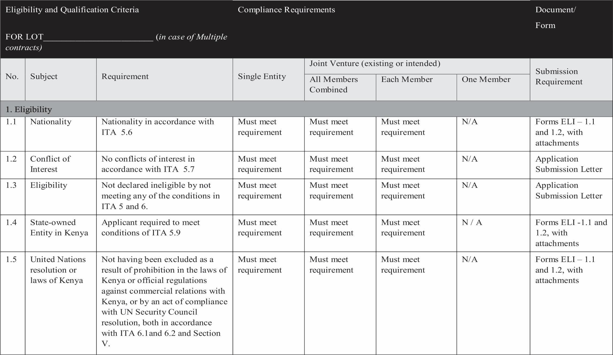
Ill

[

 |  | 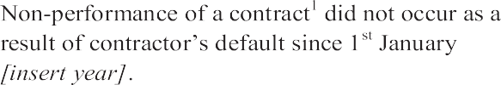
 |   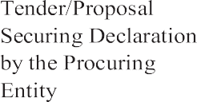 | 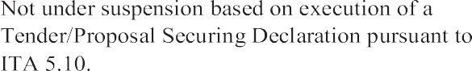
 |  | 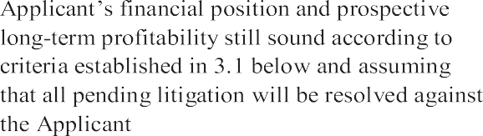
 |  | 


¹Nonperformance, as decided by the Procuring Entity, shall include all contracts where (a) nonperformance was not challenged by the contractor, including through referral to the dispute resolution mechanism under the respective contract, and (b) contracts that were so challenged but fully settled against the contractor. Nonperformance shall not include contracts where Procuring Entitys decision was overruled by the dispute resolution mechanism. Nonperformance must be based on all information on fully settled disputes or litigation, i.e. dispute or litigation that has been resolved in accordance with the dispute resolution mechanism under the respective contract and where all appeal instances available to the applicant have been exhausted.
²This requirement also applies to contracts executed by the Applicant as JV member.
³The Applicant shall provide accurate information on the related Application Form about any litigation or arbitration resulting from contracts completed or ongoing under its execution over the last five years. A consistent history of awards against the Applicant or any member of a joint venture may result in rejection of the Application.

ll
3.2 |  | by the laws of Kenya, other financial statements acceptable to the Procuring Entity, for the last [insert number] years shall be submitted and must demonstrate the current soundness of the Applicant's financial position and indicate its prospective long-term profitability. | requirement | I | Must meet requirement | NIA
3.2 | Average Annual Construction Turnover | Minimum average annual construction turnover of KENYA SHILLINGS/insert amount in KENYA SHILLING equivalent in words and figures], calculated as total certified payments received for contracts in progress and/or completed within the last [insert number] years, divided by [insert number of years in words} years | Must meet requirement | Must meet requirement | Must meet [insert number]%, [insert percentage in words} of the requirement | Must meet [insert number]%, [insert percentage in words} of the requirement | Form FIN - 3.2

7

ADDITIONAL COMPLIANCE REQUIREMENTS
Mandatory registration submissions

- Copy of the Certificate of Registration – mandatory.
- Copy of the VAT/PIN certificate of the company - mandatory
- Copy of a Valid Tax Compliance Certificate from KRA – mandatory.
- Copy of Valid business permit from Local County – mandatory.
- Copy of Valid AGPO registration certificate for reserved groups category – mandatory.
- Copy of IATA and KATA registration certificate for air travel agency firms - mandatory
- Filled, signed and stamped confidential business questionnaire.
- Declaration form – must be signed and stamped.
- Registration with relevant regulatory bodies and practicing license for Consultancy Services- Mandatory.
- CR 12 for limited companies/CR 13 for registered Names-Mandatory
- Copies of IDs for all directors-Mandatory
- License from relevant Regulatory Bodies (Private Security Regulatory Authority) for Security services -Mandatory
- Sequentially serialized document-Mandatory
Note: Failure to submit all the mandatory documents in the respective categories will lead to automatic disqualification.

SECTION IV- APPLICATION FORMS

Application Submission Letter

Date [insert day, month, and year]
ITT No. and title: .....................................................................................................................................
…………………………………………………………………… [insert ITT number and title]

To:

................................................................................................................................................................
....................................................................................................[insert full name of Procuring Entity]

We, the undersigned, apply to be Registered for the referenced ITT and declare that:
  - No reservations: We have examined and have no reservations to the Registration Document, including Addendum(s) No(s), issued in accordance with ITA 8: [insert the number and issuing date of each addendum].

  - No conﬂict of interest: We have no conﬂict of interest in accordance with ITA 5.7;

  - Eligibility: We (and our subcontractors) meet the eligibility requirements as stated ITA 5, we have not been suspended by the Procuring Entity based on execution of a Tender/Proposal-Securing Declaration in accordance with ITA 5.8;

Suspension and Debarment: We, along with any of our subcontractors, suppliers, consultants, manufacturers, or service providers for any part of the contract, are not subject to, and not controlled by any entity or individual that is subject to, a temporary suspension or a debarment imposed by the PPRA. Further, we are not ineligible under the Kenya laws or ofﬁcial regulations or pursuant to a decision of the United Nations Security Council;

State-owned enterprise or institution: [select the appropriate option and delete the other] [We are not a state- owned enterprise or institution] / [We are a state-owned enterprise or institution but meet the requirements of ITA5.9]

- Commissions, gratuities, fees: We declare that the following commissions, gratuities, or fees have been paid or are to be paid with respect to the Registration process, the corresponding Tendering process or execution of the Contract:

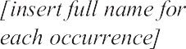
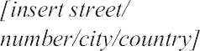
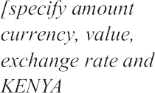

[If no payments are made or promised, add the following statement: “No commissions or gratuities have been or are to be paid by us to agents or any third party relating to this Application]

- Not bound to accept: We understand that you may cancel the Registration process at any time and that you are neither bound to accept any Application that you may receive nor to invite the registered Applicants to Tender for the contract subject of this Registration process, without incurring any liability to the Applicants, in accordance with ITA 26.1.

- True and correct: All information, statements and description contained in the Application are in all respect true, correct and complete to the best of our knowledge and belief.

Signed [insert signature(s)of an authorized representative(s)of the Applicant]

Name ………[insert full name of person signing the Application]

In the capacity of …. [insert capacity of person signing the Application]

Duly authorized to sign the Application for and on behalf of: Applicant's

Name …………….[insert full name of Applicant or the name of the JV]

Address [insert street number/town or city/country address]

Dated on [insert day number] day of [insert month], [insert year]

[For a joint venture, either all members shall sign or only the authorized representative, in which case the power of attorney to sign on behalf of all members shall be attached]

Form ELI -1.1 - Applicant Information Form

Date [insert day, month, year]

ITT No. And title: .............................................................................................................................................................
………………………………………. [ Insert ITT number and title]

Page [insert page number] of [insert total number] pages

Form ELI-1.2 - Applicant's JV Information Form

[The following form is additional to Form ELI–1.1, and shall be completed to provide information relating to each JV member (incase the Applicant is a JV) as well as any Specialized Subcontractor proposed to be used by the Applicant for any part of the Contract resulting from this Registration]

Date [insert day, month, year]

ITT No. and title: .............................................................................................................

[insert ITT number and title]

Page [insert page number] of

[insert total number] pages

Form CON 2 - Historical Contract Non-Performance, and Pending Litigation and Litigation History

The following table shall be filled in for the Applicant and for each member of a Joint Venture ]

Applicant's Name ………………………………………[insert full name]

Date: [insert day, month, year]

Joint Venture Member's Name ………………………….[insert frill name]

ITT No. and title: ………………………………………..[insert ITT number and title]

Page................... [insert page number] of [insert total number] pages
Non-Performed Contracts in accordance with Section III,
Qualification Criteria and Requirements
Contract non-performance did not occur since 1stJanuary{insert year specified in Section III, Qualification Criteria and Requirements Sub-Factor 2.1.

Contract(s) not performed since 1st January [insert year] specified in Section III, Qualification Criteria and Requirements, requirement 2.1

Year

[insert year]
Non- performed portion of contract

[insert amount and
Contract Identification

Contract Identification: [indicate complete contract name/number, and any other identification]
Name of Procuring Entity: (insert full name]
Address of Procuring Entity: (insert street/city/country]
Reason(s) for nonperformance: [indicate main reason(s)]
Total Contract Amount (current value, currency, exchange rate and KENYA SHILLING
equivalent)
[insert amount]

Pending Litigation, in accordance with Section III, Qualification Criteria and Requirements
No Litigation History in accordance with Section III, Qualification Criteria and Requirements, Sub- Factor 2.4.
Litigation History in accordance with Section IB, Qualification Criteria and Requirements, Sub-Factor
2.4 as indicated below.

Year of award

[insert year]
Outcome as percentage of Net Worth

[insert percentage]
Contract Identification

Contract Identification: [indicate complete contract name, number, and any other identification]

Name of Procuring Entity: insert full name]

Address of Procuring Entity: [insert street/c fty/country]

Matter in dispute: [indicate main issues in dispute]

Party who initiated the dispute: f indicate “Procuring Entity” or “Contractor”]

Reason(s) for Litigation and award decision [indicate
Safe reason(s)]
Total Contract Amount (currency), USD Equivalent (exchange rate)
[insert amount]

4. Form FIN – 3.1 - Financial Situation and Performance

Financial Situation and Performance

[The following table shall be ﬁlled in for the Applicant and for each member of a Joint Venture]

Applicant's Name [insert full name]

Date [insert day, month, year]

Joint Venture Member Name [insert full name]

ITT No. And title [insert ITT number and title]

Page [insert page number] of [insert total number] pages

1. Financial data



* Refer ITA 14 for the exchange rate

Sources of Finance

[The following table shall be ﬁlled in for the Applicant and all parties combined in case of a Joint Venture]

Specify sources of ﬁnance to meet the cash ﬂow requirements on works currently in progress and for future contract commitments.



Financial documents

The Applicant and its parties shall provide copies of ﬁnancial statements for [number] years pursuant Section III, Qualiﬁcations Criteria and Requirements, Sub-factor 3.1. The ﬁnancial statements shall:

    - Reﬂect the ﬁnancial situation of the Applicant or in case of JV member, and not an afﬁliated entity (such as parent company or group member).

    - Be independently audited or certiﬁed in accordance with local legislation.

    - Be complete, including all notes to the ﬁnancial statements.

    - Correspond to accounting periods already completed and audited.

Attached are copies of ﬁnancial statements1 for the [number] years required above; and complying with the requirements

N/B: Financial statements are required

1If the most recent set of ﬁnancial statements is for a period earlier than 12 months from the date of Application, the reason for this should be justiﬁed.

Form FIN - 3.2 - Average Annual Construction or Supply Contracts Turnover

[The following table shall be ﬁlled in for the Applicant and for each member of a Joint Venture] Applicant's Name [insert full name]
Date [insert day, month, year]

Joint Venture Member Name [insert full name]

ITT No. And title: [insert ITT number and title]

Page.................[insert page number] of [insert total number] pages Table A (Complete if

Contractor)


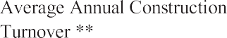

* Refer ITA 14 for date and source of exchange rate.
** Total Kenya shilling equivalent for all years divided by the total number of years. See Section III, Qualiﬁcation Criteria and Requirements, 3.2.

Table B (Complete if Supplier)



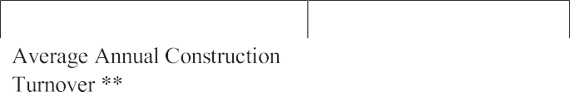
Refer ITA 15 for date and source of exchange rate.
** Total Kenya shilling equivalent for all years divided by the total number of years. See Section III, Qualiﬁcation Criteria and Requirements, 3.2.

Form EXP - 4.1 - General Construction or Supply or service Contract Experience (Select one)

[The following table shall be ﬁlled in for the Applicant and in the case of a JV Applicant, each Member]
Applicant's Name: [insert full name]

Date [insert day, month, year]

Joint Venture Member Name [insert full name]

ITT No. And title [insert ITT number and title]

Page [insert page number] of [insert total number] pages


[Identify contracts that demonstrate continuous construction work over the past [number] years pursuant to Section III, Qualiﬁcation Criteria and Requirements, Sub-Factor 4.1. List contracts chronologically, according to their commencement (starting) dates.]

 |  |  | 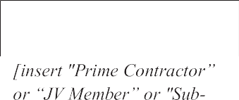
 | 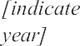 |   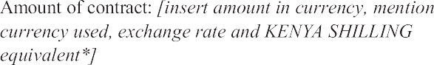


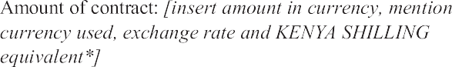



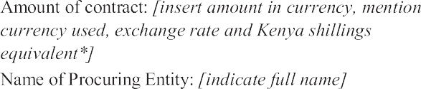

* Refer ITA 15 for date and source of exchange rate.

Form EXP - 4.2(a) - Service Contract Experience

[The following table shall be ﬁlled in for contracts performed by the Applicant, each member of a Joint Venture, and Specialized Sub-contractors]

Applicant's Name [insert full name]

Date [insert day, month, year]

Joint Venture Member Name [insert full name]

ITT No. And title [insert ITT number and title]

Page.................... [insert page number] of [insert total number] pages

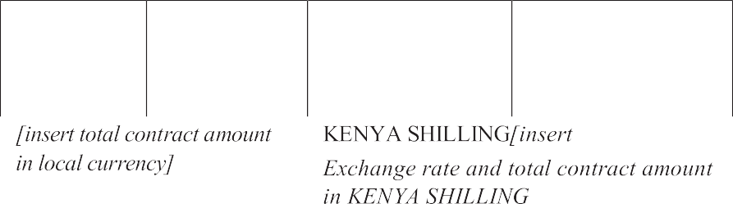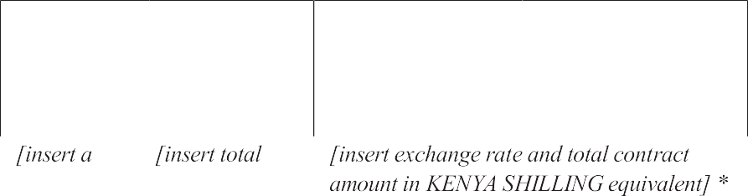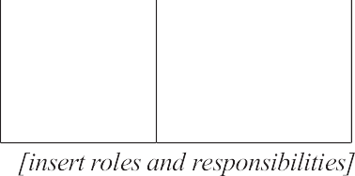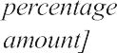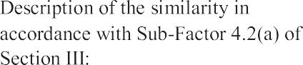
* Refer ITA 15 for date and source of exchange rate.

Form EXP - 4.2(a) (cont.) - Speciﬁc Construction and/or Contract Management Experience (cont.)

- Form EXP - 4.2(b) - Service contract in Key Activities
Applicant's Name [insert full name]

Date [insert day, month, year]

Applicant's JV Member's Name [insert full name]

Sub-contractor's Name (as per ITA 24.2 and 24.3): [insert full name]

ITT No. and title: ....................... [insert ITT number and title]

Page [insert page number] of [insert total number] pages

All Sub-contractors for key activities must complete the information in this form as per ITA 24.2 and 24.3 and Section III, Qualiﬁcation Criteria and Requirements, 4.2.

- Key Activity No. One: [insert brief description of the Activity, emphasizing its speciﬁcity] Total Quantity of Activity under the contract:



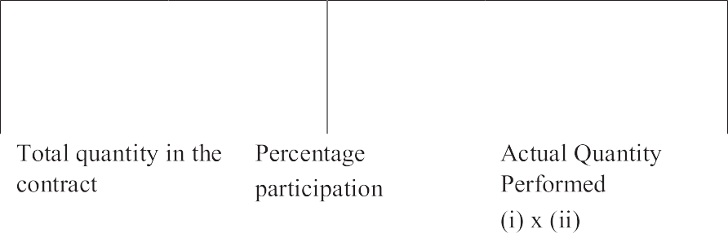
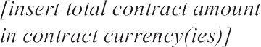
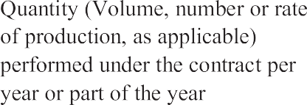
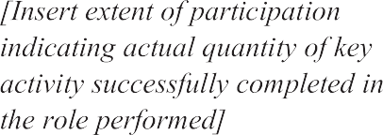

MOALF&C /VMD/REG/04/2022-2023

- Activity No. Two 3. …………………
